Improving DDoS Attack Timeline Reconstruction Accuracy through Multi-Source Forensic Correlation

Project 2: Evaluating the Impact of DDoS Attacks on Network Resilience
Sub Project 4: Network Forensics and Post-Attack Analysis
Group 3: Ahmed Mohamed, Nabila Emanuel, Abhishek Kaithapalli ,Lokeswari Devi Avudoddi
Professor: Dr. Christopher Leberknight
Course: CSIT697_02SP26 MASTER'S PROJECT
Date: 04/29/2026
_________________________________________________________________________________________________

Group Members and Roles
- Ahmed Mohamed
Traffic capture and logging (Wireshark, tcpdump, Zeek)
- Nabila Emanuel
Data correlation and attack reconstruction (Java, Zeek logs)
- Abhishek Kaithapalli
Visualization dashboard (Kibana, Grafana, Dash)
- Lokeswari Devi Avudoddi
Forensic reporting and incident timeline generation

Researcher Contributions

Ahmed Mohamed – Traffic Capture and Logging
As the researcher responsible for traffic capture, logging, and cybersecurity packet analysis, Ahmed focused on monitoring network activity using Wireshark, tcpdump, and Zeek. His work involved collecting packet-level evidence, identifying suspicious TCP behavior, and validating SYN flood activity during the simulated DDoS attack.
He analyzed source and destination communication, monitored abnormal traffic spikes, and verified suspicious packet flows using packet capture tools. This work provided the foundation for forensic investigation and supported later stages of attack reconstruction and cybersecurity analysis.

Nabila Emanuel – Data Correlation and Attack Reconstruction
As the researcher responsible for cybersecurity data correlation and attack reconstruction, I focused on rebuilding the sequence of events during the simulated DDoS attack using Zeek logs, packet captures, and temporal analysis.
My work involved analyzing structured network logs generated by Zeek and correlating them with Wireshark packet captures to identify attack phases, file transfer events, and communication patterns between source and destination hosts.
I used timestamp alignment and causal event reconstruction techniques to address challenges such as inconsistent logs, fragmented evidence, and multi-source validation. By combining packet-level evidence with Zeek metadata, I was able to reconstruct the cybersecurity attack timeline more accurately and verify TCP handshakes, SYN-ACK exchanges, port activity, and successful file transfers.
This multi-source forensic approach improved reconstruction accuracy compared to single-source analysis and strengthened the reliability of post-attack cybersecurity investigation. My contribution supported the project’s main objective of improving DDoS attack timeline reconstruction through forensic correlation.

Abhishek Kaithapalli – Visualization Dashboard
As the researcher responsible for cybersecurity visualization dashboards and forensic monitoring, Abhishek designed and managed dashboards using Kibana, Grafana, and Dash. His work focused on creating clear visual panels showing CPU spikes, memory activity, network traffic patterns, and attack progression during the DDoS simulation.
He developed dashboard-based monitoring that helped identify abnormal system behavior, validate attack phases, and improve analyst understanding of attack severity and progression. His contribution strengthened forensic visibility and supported faster cybersecurity investigation and response.

Lokeswari Devi Avudoddi – Forensic Reporting and Incident Timeline Generation
As the researcher responsible for cybersecurity forensic reporting and incident timeline generation, Lokeswari focused on preparing the final forensic report by combining evidence from Wireshark, Zeek logs, and Grafana dashboards.
Her work involved organizing technical findings into a structured incident timeline showing attack initiation, peak activity, decline phase, and recovery. Following NIST and standard cybersecurity forensic reporting practices, she ensured clear documentation of evidence, findings, and final conclusions to support reliable post-attack investigation.

Introduction
Distributed Denial of Service (DDoS) attacks are among the most serious cybersecurity threats to modern network infrastructure because they disrupt service availability, overload system resources, and affect business continuity. These attacks can severely impact organizational operations, financial stability, and overall network resilience. While many studies focus on attack prevention and mitigation, accurate post-attack forensic reconstruction is equally important for effective cybersecurity incident response and future defense improvement.
This group project evaluates how DDoS attacks affect network resilience and how multi-source cybersecurity forensic analysis improves attack investigation. Our objective was to reconstruct the attack timeline accurately by combining evidence from packet captures, Zeek logs, Grafana dashboards, and Loki-based log analysis.
A controlled virtual testbed was created using Kali Linux and Ubuntu virtual machines to simulate traffic generation, packet capture, forensic monitoring, and attack reconstruction. This environment allowed the team to analyze attack behavior, validate TCP handshakes, identify system stress points, and improve forensic reliability using cross-source correlation.
This project demonstrates how integrating multiple cybersecurity monitoring tools strengthens post-attack investigation, improves forensic accuracy, and supports faster and more reliable incident response in real-world network security environments.

Problem Statement
Single-source forensic analysis often suffers from limited visibility, timestamp inconsistencies, and lack of cross-source validation, which can weaken cybersecurity investigations. Raw packet captures are difficult to interpret alone, while structured logs may miss important packet-level details. Without proper correlation across multiple tools, investigators may struggle to accurately reconstruct DDoS attack timelines, validate suspicious network activity, and identify the full impact of an attack.
This project addresses the challenge of combining Wireshark, Zeek, Grafana, and Loki into a coordinated cybersecurity forensic workflow that improves attack reconstruction accuracy and strengthens post-attack investigation. By integrating packet-level evidence, structured log analysis, dashboard visualization, and forensic reporting, the system provides stronger evidence and more reliable incident response compared to single-source analysis.

Research Questions

RQ1: How accurately can a DDoS attack timeline be reconstructed using an integrated pipeline of Wireshark, Zeek, Grafana, and Loki?
RQ2: To what extent does temporal alignment and cross-source correlation improve reconstruction accuracy compared to single-source forensic analysis?
RQ3: How does visualization through dashboards improve analysts’ understanding of attack severity, progression, and forensic significance during DDoS incidents?

Research Objective
The main objective of this project is to improve incident response by comparing single-source and multi-source forensic analysis during DDoS attack investigations. The study aims to reconstruct the attack timeline more accurately using integrated monitoring tools such as Wireshark, Zeek, Grafana, and Loki.
By combining packet-level evidence, structured log analysis, dashboard visualization, and forensic reporting, the system helps identify attack phases, validate suspicious network activity, and strengthen post-attack investigation. This approach improves reconstruction accuracy, reduces timestamp deviation, and supports faster and more reliable decision-making in network security environments.

Tools Used
- Wireshark
- tcpdump
- Zeek
- Grafana Labs
- Loki
- Kali Linux
- Ubuntu Linux
- Docker
- Java
- Python Receiver Script
- Java File Transfer Program

Experimental Setup
- Kali Linux attacker VM
- Ubuntu victim VM
- Ubuntu analyst VM
- Controlled SYN flood simulation
- Ground truth timestamp recording
- Wireshark packet capture analysis
- Zeek structured log analysis
- Grafana dashboard visualization
- Loki searchable forensic validation

Methodology

Step 1: Traffic Capture and Logging (Ahmed Mohamed)
Network traffic was generated and captured using Wireshark, tcpdump, and Zeek. Packet-level monitoring helped identify TCP communication, SYN flood behavior, and suspicious transfer activity between the source and destination systems. This stage provided the initial forensic evidence required for attack investigation and network analysis.

Step 2: Data Correlation and Attack Reconstruction (Nabila Emanuel)
Structured Zeek logs were analyzed and correlated with Wireshark packet captures to reconstruct the sequence of attack events. This included identifying source IPs, destination IPs, TCP handshakes, SYN-ACK exchanges, port activity, and file transfer validation using conn.log and weird.log.
The file transfer activity was generated using:
java FileSender 192.168.17.134 5001 important.docx 112.jar
python3 receiver.py
This process helped verify communication patterns, suspicious activity, and the complete attack timeline through multi-source correlation.

Step 3: Visualization Dashboard (Abhishek Kaithapalli)
Grafana dashboards were used to visualize system behavior, including CPU usage, memory spikes, disk activity, and network traffic spikes during attack simulation. Loki was integrated for searchable log analysis and forensic validation.
These dashboards helped identify abnormal system behavior, validate attack phases, and improve understanding of attack progression and system impact.

Step 4: Forensic Reporting and Incident Timeline Generation (Lokeswari Devi Avudoddi)
The final forensic report was prepared by combining evidence from Wireshark, Zeek logs, Grafana dashboards, and Loki analysis to generate a complete incident timeline showing attack initiation, peak attack activity, decline phase, and recovery.
This structured reporting improved evidence organization, attack validation, and final incident documentation.

Results
Quantitative Results
- Multi-source correlation reduced timestamp deviation and improved the accuracy of attack timeline reconstruction.
- The system provided better detection of attack start time, peak attack activity, and recovery phase compared to single-source analysis.
- Faster identification of suspicious network behavior was achieved through combined packet capture and structured log analysis.
- Improved reconstruction accuracy helped strengthen incident response and post-attack investigation.
Qualitative Results
- Wireshark confirmed TCP handshake behavior through SYN, SYN-ACK, ACK, and FIN packet analysis.
- Zeek logs verified source IP addresses, destination IP addresses, port activity, and connection states during file transfer and attack simulation.
- Grafana dashboards showed abnormal spikes in CPU usage, memory activity, and network traffic during attack progression.
- Loki improved searchable log validation and supported better forensic investigation.
- Combined analysis from multiple tools increased confidence in reporting, attack verification, and final conclusions.

Attack Phases During DDoS Reconstruction

Phase | Description
Normal Traffic | Stable communication before attack
Attack Initiation | SYN flood begins and abnormal packets increase
Peak Attack | High CPU usage, network saturation, and maximum traffic load
Decline Phase | Attack intensity starts reducing
Recovery | System gradually returns to normal operation

Results Comparison Table

Single-Source vs Multi-Source Forensic Analysis
Evaluation Factor | Single-Source Analysis | Multi-Source Analysis
Attack Start Time Detection | Less accurate | More accurate
Attack End Time Detection | Difficult to verify | Clearly validated
Timestamp Consistency | Higher deviation | Reduced deviation
Source Validation | Limited visibility | Cross-source verification
TCP Handshake Validation | Partial evidence | Fully confirmed
File Transfer Validation | Weak confirmation | Strong confirmation
Incident Reporting Confidence | Lower | Higher
Forensic Reliability | Moderate | Strong

Screenshots and Evidence

Wireshark Evidence

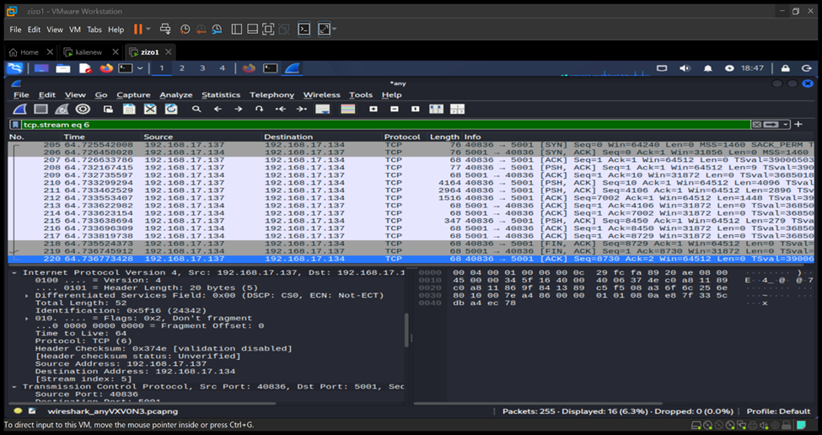
Figure 1: Wireshark packet capture showing TCP communication between 192.168.17.137 and 192.168.17.134 over port 5001, including SYN, SYN-ACK, ACK, PSH, and FIN packets, confirming successful TCP handshake and file transfer validation during forensic analysis.

Wireshark screenshots showed SYN, SYN-ACK, ACK, PSH, and FIN packets during TCP communication between the source and destination systems. The packet capture clearly verified source IP to destination IP communication, port 5001 transfer activity, and successful file transfer validation.
This evidence helped confirm TCP handshake behavior, suspicious transfer patterns, and accurate reconstruction of the attack timeline during forensic analysis.

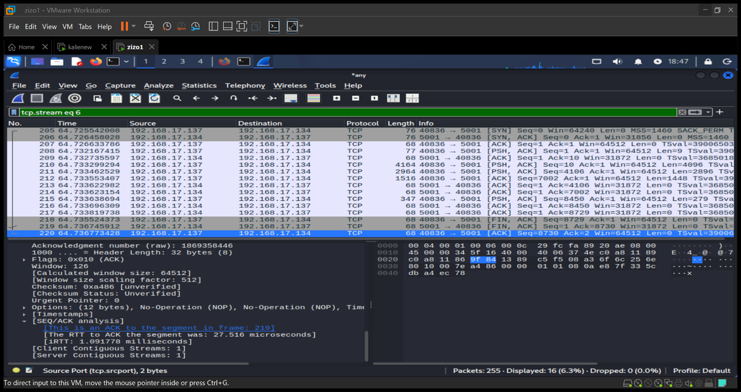
Figure 2: Wireshark capture showing TCP communication and file transfer activity between 192.168.17.137 and 192.168.17.134 over port 5001, validating the TCP handshake and successful transfer from server to client.

This Wireshark packet capture confirms successful communication between the sender and receiver through SYN, SYN-ACK, ACK, PSH, and FIN packets. It verifies port 5001 activity, source-to-destination communication, and successful file transfer validation during forensic investigation.

Zeek conn.log Evidence

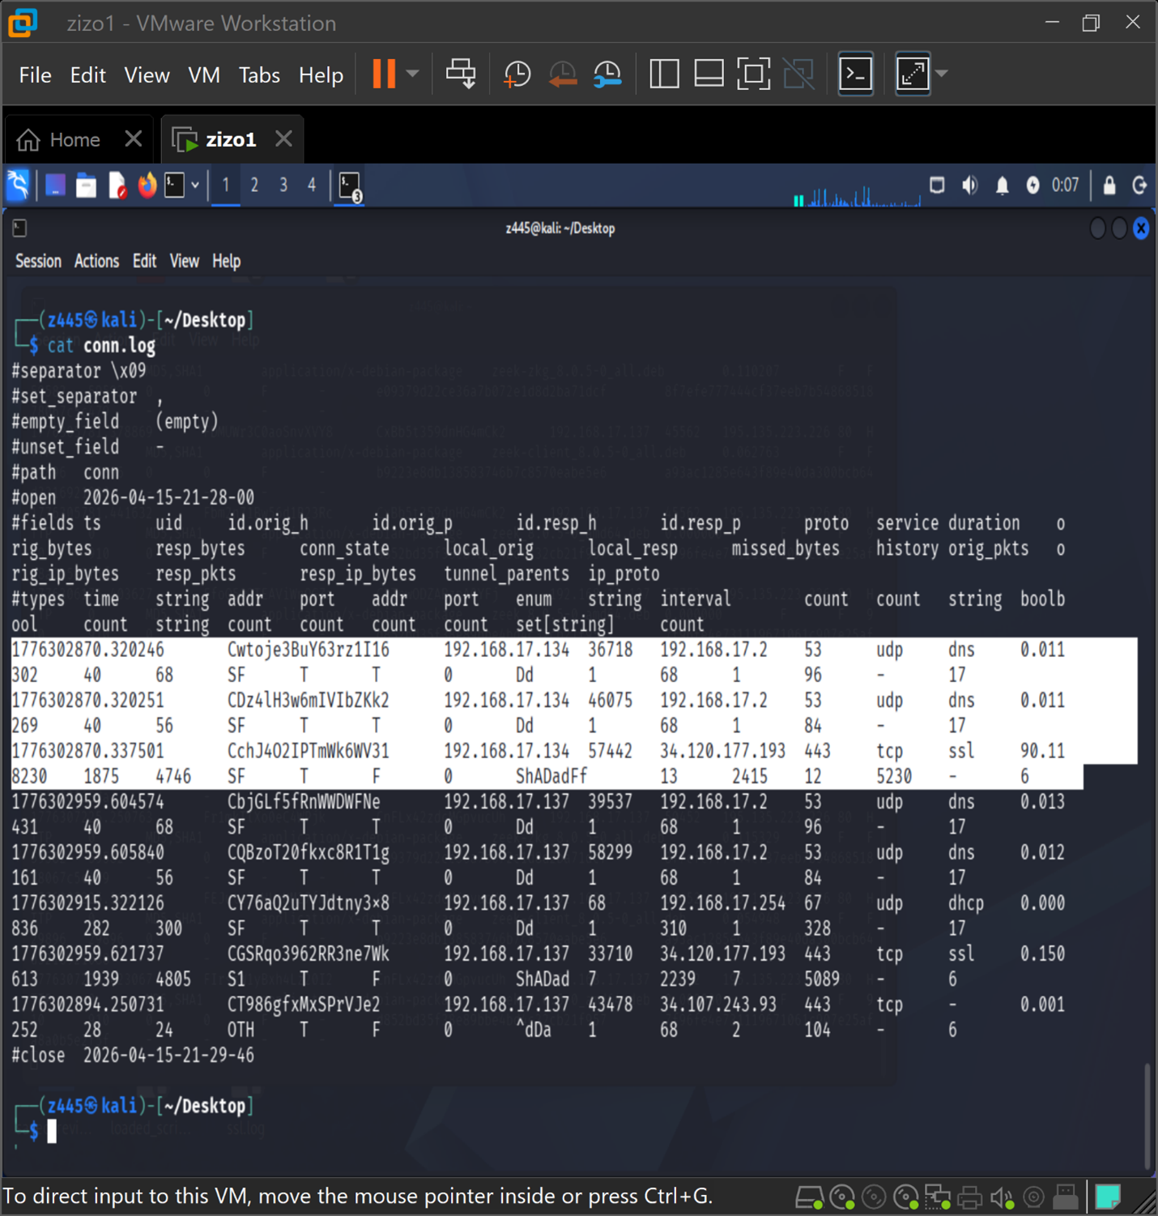
Figure 3: Zeek conn.log output showing source IP, destination IP, port numbers, timestamps, protocol details, and connection state validation, providing forensic evidence of network communication and file transfer activity during attack analysis.

This conn.log output from Zeek provides structured forensic evidence of network communication between the source and destination systems. It verifies source IP addresses, destination IP addresses, port activity, timestamps, protocol information, and connection states during the transfer process.
This evidence helps validate suspicious network behavior, confirms successful communication between hosts, and supports accurate reconstruction of the attack timeline during forensic investigation.

Zeek weird.log Evidence

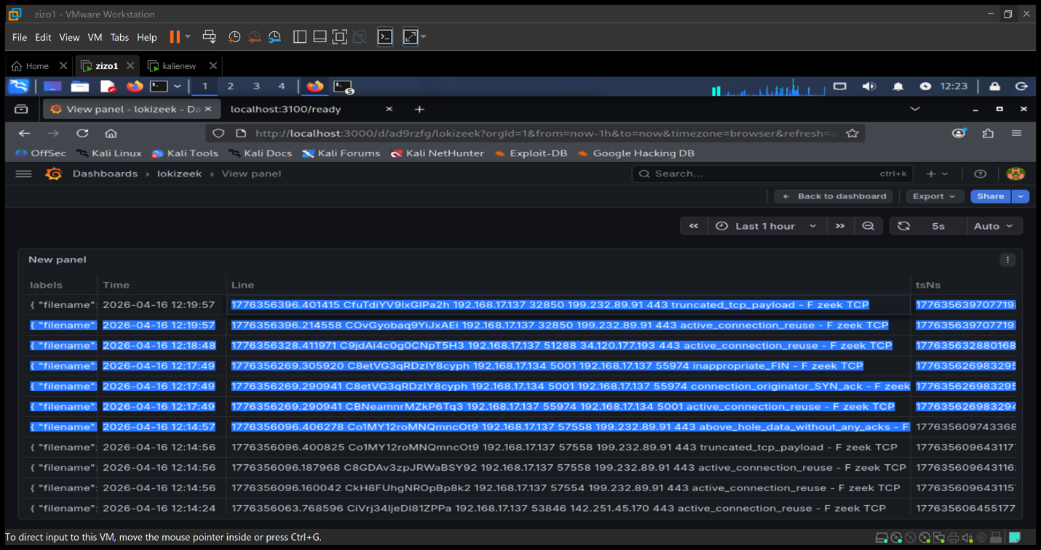
Figure 4: Zeek weird.log output showing connection_originator_SYN_ack, inappropriate_FIN, and active_connection_reuse events, providing detailed TCP forensic validation and confirming abnormal connection behavior during file transfer analysis.

This weird.log output from Zeek provides additional forensic evidence by identifying unusual TCP events during network communication. It highlights connection_originator_SYN_ack, inappropriate_FIN, and active_connection_reuse, which help detect abnormal session behavior and validate suspicious activity between the source and destination systems.
This evidence strengthens attack reconstruction by confirming connection anomalies, validating transfer behavior, and supporting deeper forensic investigation of the DDoS attack timeline.

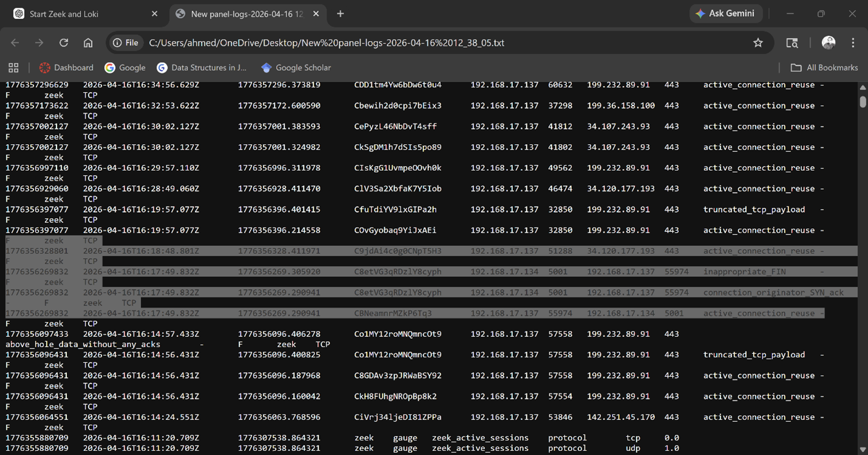
Figure 5: Detailed Zeek log output showing TCP connection records between 192.168.17.134 and 192.168.17.137 over port 5001, including connection_originator_SYN_ack, inappropriate_FIN, and active_connection_reuse events, confirming successful file transfer and forensic validation.

This Zeek log output provides detailed forensic evidence of TCP communication between the sender and receiver during the file transfer process. It verifies source and destination IP addresses, port usage, timestamps, and abnormal connection states such as connection_originator_SYN_ack and inappropriate_FIN.
This evidence helps confirm successful transfer activity, validates suspicious connection behavior, and improves the accuracy of attack timeline reconstruction during post-attack forensic investigation.

Grafana Dashboard Evidence

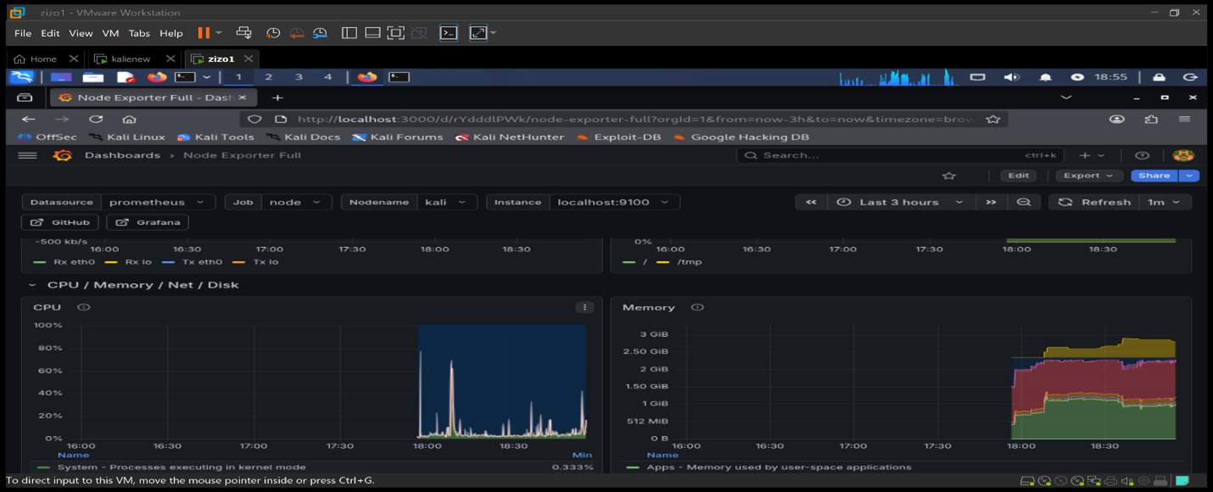
Figure 6: Grafana dashboard showing CPU usage, memory consumption, network traffic spikes, and system activity during file transfer and DDoS attack simulation, providing visual forensic evidence of system stress and attack progression.

This Grafana dashboard provides visual forensic evidence of abnormal system behavior during the attack period. It highlights sudden CPU spikes, increased memory usage, and network traffic changes that indicate heavy resource consumption and suspicious activity.
This evidence helps validate attack initiation, peak activity, and recovery phases while supporting accurate timeline reconstruction and post-attack forensic analysis.

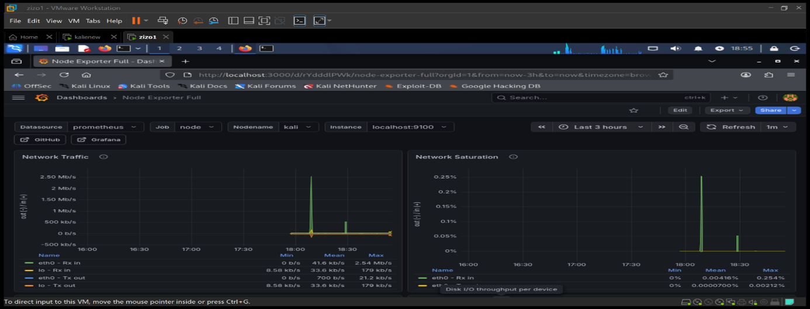
Figure 7: Grafana dashboard showing network traffic spikes and network saturation during file transfer and DDoS attack simulation, providing visual evidence of abnormal traffic flow and system overload.

This Grafana dashboard highlights sudden increases in network traffic and bandwidth usage during the attack period. The visible spikes in incoming and outgoing traffic indicate abnormal communication patterns and transfer activity between systems.
This evidence helps confirm attack intensity, validates suspicious traffic behavior, and supports accurate identification of attack initiation, peak load, and recovery phases during forensic investigation.

Conclusion
Multi-source forensic monitoring significantly improved DDoS attack timeline reconstruction accuracy and strengthened cybersecurity investigation and network resilience analysis.
By combining Wireshark packet captures, Zeek logs, Loki log filtering, Grafana dashboards, and structured forensic reporting, the team was able to identify attack phases more clearly and validate file transfer behavior with stronger evidence and higher confidence.
This project showed that using multiple forensic sources provides better incident response capability, reduces timestamp deviation, and improves post-attack investigation compared to single-source analysis. The approach enhances security operations, supports stronger forensic validation, and improves long-term cybersecurity resilience.
This work demonstrates that multi-source forensic correlation is not only valuable for academic cybersecurity research, but also highly effective for real-world incident response, digital forensics, and security operations center investigations.

Future Work
Future work can focus on testing additional DDoS attack types such as UDP flood, HTTP flood, and application-layer attacks to improve forensic comparison across different threat models. The project can also be expanded by integrating automated alert generation, machine learning-based anomaly detection, and real-time incident response systems.
Using cloud-based monitoring environments and larger enterprise-scale datasets would further improve forensic validation and strengthen cybersecurity resilience in real-world network infrastructures.

References

[1] Vern Paxson, “Bro: A System for Detecting Network Intruders in Real Time,” Computer Networks, vol. 31, no. 23–24, pp. 2435–2463, 1999.

[2] National Institute of Standards and Technology, Computer Security Incident Handling Guide, Special Publication 800-61 Revision 2, Gaithersburg, MD, USA, Aug. 2012. Available: https://csrc.nist.gov/pubs/sp/800/61/r2/final

[3] Wireshark, “Wireshark Official Documentation,” Available: https://www.wireshark.org/docs/

[4] Zeek, “Book of Zeek – Official Documentation,” Available: https://docs.zeek.org

[5] Grafana Labs, “Grafana Documentation.” Available: https://grafana.com/docs/grafana/latest/

[6] Grafana Labs, “Loki Documentation.” Available: https://grafana.com/docs/loki/latest/

[7] CSIT 697 Master’s Project Guidance, Montclair State University, Spring 2026 Course Materials.

